**A step closer to solving one of the biggest mysteries in fundamental physics?**

June 15, 2011

**[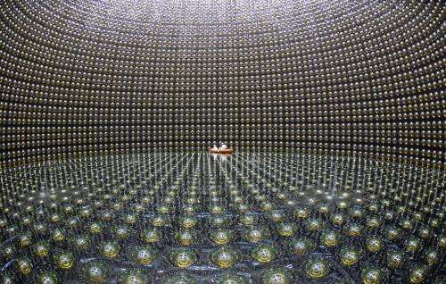](http://cdn.phys.org/newman/gfx/news/hires/2011/t2kph20.jpg)**

Credit: Univeristy of Tokyo

(PhysOrg.com) -- Where did all the matter in the universe come from? This is one of the biggest mysteries in fundamental physics and exciting results released on 15 June 2011 from the international T2K neutrino experiment in Japan could be an important step towards resolving this puzzle.

The intriguing results indicate a new property of the enigmatic [particles](http://www.physorg.com/tags/particles/) known as [neutrinos](http://www.physorg.com/tags/neutrinos/).

There are three types of neutrinos (called flavours) - one paired by particle interactions with the familiar electron (called the electron neutrino), and two more paired with the electron's heavier cousins, the muon and tau leptons. Previous experiments around the world have shown that these different flavours of neutrinos can spontaneously change into each other, a[phenomenon](http://www.physorg.com/tags/phenomenon/) called 'neutrino oscillation'.

Two types of oscillations have already been observed but in its first full period of operation, the T2K experiment has already seen evidence for a new type of oscillation (the appearance of electron neutrinos in a muon neutrino beam). This means that we have now observed that neutrinos can oscillate in every way possible.

This level of complexity opens the possibility that the oscillations of neutrinos and their anti-particles (called anti-neutrinos) could be different. And if the oscillations of neutrinos and anti-neutrinos are different, it would be an example of what[physicists](http://www.physorg.com/tags/physicists/) call CP violation. This could be the key to explaining why there is more matter than [anti-matter](http://www.physorg.com/tags/anti+matter/) in the universe (an excess which could not happen within the known [laws of physics](http://www.physorg.com/tags/laws+of+physics/)).

The experiment ran from January 2010 until 11 March this year, when it was dramatically interrupted by the Japanese earthquake. Fortunately, the multinational T2K team were unharmed and their highly sensitive detectors were largely undamaged. Six clean electron neutrino events are observed in the data from before the earthquake, while in the absence of oscillations there should only have been 1.5. Even though such an excess could only happen by chance about one time in a hundred, that is not good enough to confirm a new physics discovery, so this is called an 'indication'.

Prof Dave Wark of STFC and Imperial College London, who served for four years as the International Co-Spokesperson of the experiment and is head of the UK group, explains, "People sometimes think that scientific discoveries are like light switches that click from 'off' to 'on', but in reality it goes from 'maybe' to 'probably' to 'almost certainly' as you get more data. Right now we are somewhere between 'probably' and 'almost certainly'."  
  
Read more at: <http://phys.org/news/2011-06-closer-biggest-mysteries-fundamental-physics.html#jCp>

Prof Christos Touramanis from Liverpool University is the Project Manager for the UK contributions to T2K: "We have examined the near detectors and turned some of them back on, and everything that we have tried works pretty well. So far it looks like our earthquake engineering was good enough, but we never wanted to see it tested so thoroughly."

Prof Takashi Kobayashi of the KEK Laboratory in Japan and spokesperson for the T2K experiment, said "It shows the power of our experimental design that with only 2% of our design data we are already the most sensitive experiment in the world for looking for this new type of oscillation."

**About T2K**

The experiment is a huge undertaking with over 500 scientists from 12 countries. The UK has invested £14.3M in the T2K project.

There are three elements to the experiment:

• A beam of muon neutrinos is produced at the Japan Proton Accelerator Research Center in Tokai, Japan. STFC engineers from the Rutherford Appleton Laboratory helped in the design, production, and testing of a number of the elements of this neutrino production system.

• The neutrinos then pass through a [complex](http://www.physorg.com/tags/complex/) set of near detectors located 280 meters from the target in order to determine the neutrino beam's composition and properties before the neutrinos have a chance to oscillate. 8 STFC-supported institutions (listed below) were involved in the production of a variety of components for these near detectors.

• The neutrinos then fly under the ground for 295 km across Japan to the mammoth Super Kamiokande neutrino detector (a tank of 50,000 tons of ultra-pure water surrounded by sensitive optical detectors which can see the very faint flashes of light emitted by the very rare interactions of passing neutrinos with the water). This is capable of telling muon neutrinos from electron neutrinos with high precision, and is thus ideal for looking for the appearance of a small fraction of electron neutrinos appearing in the muon neutrino beam, the key signature of this new type of oscillation.

**Evidence mounts that neutrinos are the key to the universe's existence**

August 8, 2016 by Hayley Dunning

**[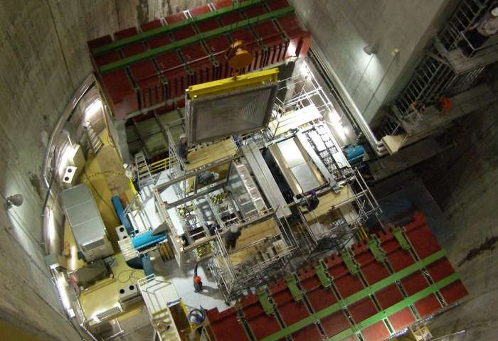](http://cdn.phys.org/newman/gfx/news/2016/57a86fd484929.jpg)**

The T2K near detector. Credit: Imperial College London

New experimental results show a difference in the way neutrinos and antineutrinos behave, which could explain why matter persists over antimatter.

The results, from the T2K experiment in Japan, show that the degree to which[neutrinos](http://phys.org/tags/neutrinos/) change their type differs from their antineutrino counterparts. This is important because if all types of matter and antimatter behave the same way, they should have obliterated each other shortly after the Big Bang.

So far, when scientists have looked at matter-antimatter pairs of particles, no differences have been large enough to explain why the universe is made up of matter – and exists – rather than being annihilated by antimatter.

Neutrinos and antineutrinos are one of the last matter-antimatter pairs to be investigated since they are difficult to produce and measure, but their strange behaviour hints that they could be the key to the mystery.

**Flavour change**

Neutrinos (and antineutrinos) come in three 'flavours' of tau, muon and electron, each of which can spontaneously change into the other as the neutrinos travel over long distances.

The latest results, announced today by a team of researchers including physicists from Imperial College London, show more[muon neutrinos](http://phys.org/tags/muon+neutrinos/) changing into electron neutrinos than muon antineutrinos changing into electron antineutrinos.

This difference in muon-to-electron changing behaviour between neutrinos and antineutrinos means they would have different properties, which could have prevented them from destroying each other and allow the universe to exist.

To explore the (anti)neutrino flavour changes, known as osciallations, the T2K experiment fires a beam of (anti)neutrinos from the J-PARC laboratory at Tokai Village on the eastern coast of Japan.

It then detects them at the Super-Kamiokande detector, 295 km away in the mountains of the north-western part of the country. Here, the scientists look to see if the (anti)neutrinos at the end of the beam matched those emitted at the start.

**Very intriguing**

The latest results were concluded from relatively few data points, meaning there is still a one in 20 chance that the results are due to random chance, rather than a true difference in behaviour. However, the result is still exciting for the scientists involved.

Dr Morgan Wascko, international co-spokesperson for the T2K experiment from the Department of Physics at Imperial said: "This is an important first step towards potentially solving one of the biggest mysteries in science.

"T2K is the first experiment that is able to study neutrino and antineutrino oscillation under the same conditions, and the disparity we have observed is, while not yet statistically significant, very intriguing."

Dr Yoshi Uchida, also from the Department of Physics at Imperial and a principal investigator at T2K, added: "More data is needed to prove conclusively that neutrinos and antineutrinos behave differently, but this result is an indication that neutrinos will continue to provide breakthroughs in our understanding of the universe.

Upgrades to the equipment that produces (anti)neutrinos, as well as to the detector that measures them, are expected to add more data within the next decade, and determine whether the difference is in fact real.

Read more at: <http://phys.org/news/2016-08-evidence-mounts-neutrinos-key-universe.html#jCp>

[COSMOS CONVERSATION](https://cosmosmagazine.com/sections/cosmos-conversation) [PHYSICS](https://cosmosmagazine.com/topics/physics) 26 JULY 2016

4 MINUTE READ

READ LATERTOGGLE DROPDOWN

SHARE TOTOGGLE DROPDOWN

From dark gravity to phantom energy: what’s driving the expansion of the universe?

There is something strange happening in the local universe, with galaxies moving away from each other faster than expected. What is driving this extra expansion, and what does it mean for the cosmos?

**There is something strange happening in the local universe**, with galaxies moving away from each other[faster than expected](http://www.science20.com/news_articles/the_universe_is_expanding_even_faster_than_believed-173999).

What is driving this extra expansion, and what does it mean for the cosmos? To explore this, let’s start with the observations.

RECOMMENDED

[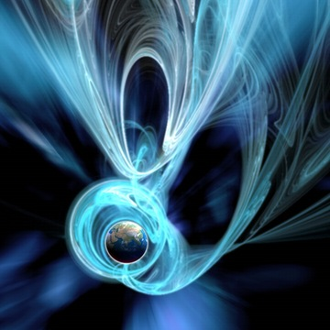](https://cosmosmagazine.com/physics/the-dark-side-of-the-universe-a-primer)

[The dark side of the universe – a primer](https://cosmosmagazine.com/physics/the-dark-side-of-the-universe-a-primer)

[PHYSICS](https://cosmosmagazine.com/topics/physics) Premium Article

The rate of cosmic expansion is encapsulated in the “[Hubble constant](http://hyperphysics.phy-astr.gsu.edu/hbase/astro/hubble.html)”, although don’t let the name fool you, as it’s not a constant and changes as the universe expands.

To determine this constant, astronomers must relate the distances to galaxies to the velocity they’re travelling away from us. But measuring astronomical distances has always proven difficult. This is because we lack convenient signposts, known as [standard candles](http://hyperphysics.phy-astr.gsu.edu/hbase/astro/stdcand.html) and [rulers](http://philosophy-of-cosmology.ox.ac.uk/standard-rulers.html), to chart the heavens.

So astronomers have built up cosmic distances through a series of steps, using overlapping methods to span the heavens. But each step in this[cosmological distance ladder](https://terrytao.files.wordpress.com/2010/10/cosmic-distance-ladder.pdf) has its own quirks and uncertainties, and extraordinary effort over many decades has been expended to calibrate the various methods.

A new [paper](https://arxiv.org/pdf/1604.01424.pdf) has pushed this calibration even harder, using a number of methods to tie down the Hubble constant to an accuracy of 2.4% within a few hundred million light years (which is local by cosmic standards).

A great success! But there’s a problem.

We can also determine the universal expansion from observations of the [cosmic microwave background](http://astronomy.swin.edu.au/cosmos/C/Cosmic+Microwave+Background), which is the radiation leftover from the [Big Bang](http://www.universetoday.com/54756/what-is-the-big-bang-theory/).

Unlike local observations, this reveals the global expansion of the universe. And this is where the problems begin, as this global expansion is 9% slower than that seen in the local universe. In both measurements, the astronomers have worked hard to reduce the uncertainties, and so are confident this difference is valid.

So what can explain this tension in cosmic measurement? Here are a few of the contenders.

Cosmic contenders

Dark matter

The first potential culprit is [dark matter](http://www.space.com/20930-dark-matter.html), the dominant *mass* in the universe. We know it is not smoothly spread through space, so perhaps the lumps and bumps, like the galaxies and clusters of galaxies, are exacting less gravitational pull in the local universe.

RECOMMENDED

[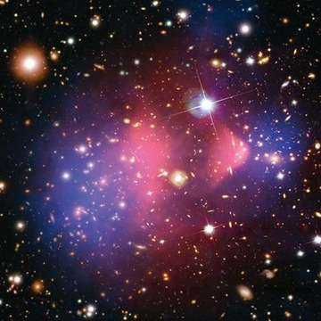](https://cosmosmagazine.com/space/dark-matter-uncovered)

[Dark matter uncovered](https://cosmosmagazine.com/space/dark-matter-uncovered)

[SPACE](https://cosmosmagazine.com/topics/space) Premium Article

Perhaps we are in a [cosmic void](http://www.universetoday.com/15719/the-cosmic-void-could-we-be-in-the-middle-of-it/), a region whose density is below the universal average.

If this were the case, we would have to be inhabiting a strange corner of the universe, sitting at the centre of immense emptiness not very unlike anything expected in our [cosmological ideas](http://astronomy.swin.edu.au/cosmos/L/large-scale+structure).

Dark energy

And then there is [dark energy](http://hetdex.org/dark_energy/dark_matter.php), the dominant *energy* in the universe. This component is responsible for accelerating the cosmic expansion, but is assumed to have a very simple form, eternal and unchanging over all of history.

But what if dark energy is dynamic and evolving, changing its properties as the universe expands? If it changed quite recently (in cosmic terms), the additional expansion could be imprinted on the local universe, but have not yet impacted the global expansion.

If this is the case, the universe has something to worry about, as this new form of dark energy would be a “[phantom](https://www.physics.rutgers.edu/~saurabh/690/Mar27-Zhang-phantom.pdf)”, driving universal expansion faster and faster into a “[big rip](http://www.telegraph.co.uk/news/science/science-news/11715091/Big-Rip-will-end-the-universe-scientists-claim.html)”, which is more dramatic than it sounds.

[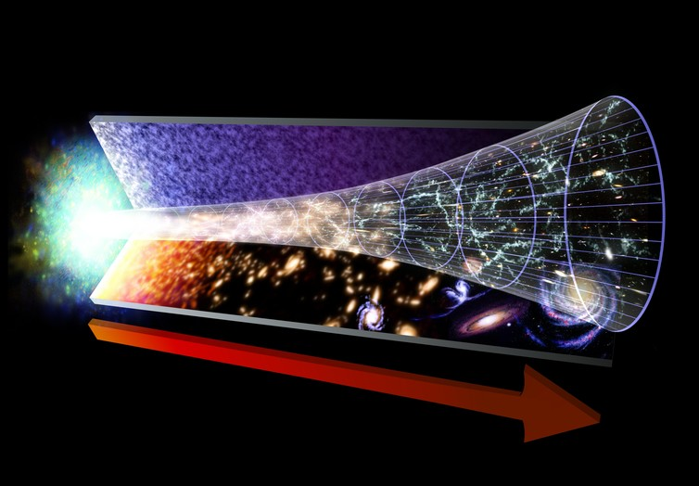](https://62e528761d0685343e1c-f3d1b99a743ffa4142d9d7f1978d9686.ssl.cf2.rackcdn.com/files/125320/area14mp/image-20160606-25985-3ass74.jpg)A diagram representing the evolution of the universe, starting with the Big Bang to present day. The red arrow marks the flow of time. New research suggests it’s expanding even faster than shown here. NASA/GSFC

Dark radiation

Another potential solution is “dark radiation”, which consists of hyper-fast particles that zipped around in the early universe.

While there is no single definition on what constitutes dark radiation, a favoured candidate is a new member of the[neutrino family](http://www.ps.uci.edu/~superk/neutrino.html), affectionately known as [sterile neutrinos](http://www.quantumdiaries.org/2014/07/27/sterile-neutrinos/).

While dark radiation is theoretical, there is little observational evidence for its existence. But if it had been present in the early universe, it would have influenced the early expansion of the universe, which would still be imprinted on the global value of the Hubble constant, but would now be washed out of the local value.

Dark gravity

The potential solutions so far have considered modifying the properties of components in the universe, but there is the more drastic alternative: [dark gravity](http://arxiv.org/abs/0711.0077).

This suggests that we don’t fully understand the fundamental nature of the universe, and that gravity does not follow the rules laid out by [Albert Einstein](http://www.nobelprize.org/nobel_prizes/physics/laureates/1921/einstein-bio.html) in his [general theory of relativity](https://www.newscientist.com/round-up/instant-expert-general-relativity/).

Such theories of [modified gravity](http://arxiv.org/pdf/1106.2476v3.pdf) have existed for a long time, and come in many forms, and it is not clear how we deduce the impact of such gravity on the universal expansion.

Dark speculations

So there are several alternatives that could potentially explain the discrepancy between the local and global measurements of the Hubble constant. Which one is correct?

At the moment, the observations are rather raw and do not discriminate between the possibilities. And so we enter the realm of theoretical speculation, where ideas are tried and discarded until viable explanations are discovered.

RECOMMENDED

[The problem with dark matter](https://cosmosmagazine.com/physics/problem-dark-matter)

[PHYSICS](https://cosmosmagazine.com/topics/physics) Premium Article

At the same time, astronomers will seek more data, and will continue to tie down calibrations and methods. This brings us to our final possibility.

No observations are perfect, and much of science is about understanding the uncertainties of measurements. Scientists can generally wrangle [random errors](https://explorable.com/random-error) and understand how uncertainties in measurement impact uncertainties in results.

But there is another uncertainty: the [systematic error](http://www.physics.umd.edu/courses/Phys276/Hill/Information/Notes/ErrorAnalysis.html), which can strike fear into a researcher. Instead of scattering results, systematic errors shift all results one way or another.

Systematic errors can also influence astronomical distance measures. And if they propagate through the distance ladder, they could potentially shift the local measurement of the Hubble constant away from the global value.

With new data and methods, this tension may evaporate. Some astronomers are already suggesting that this is a[“more reasonable explanation”](https://arxiv.org/pdf/1606.00634.pdf).

[EXPLAINER](https://cosmosmagazine.com/sections/explainer) [PHYSICS](https://cosmosmagazine.com/topics/physics) 09 MAY 2016

6 MINUTE READ

READ LATERTOGGLE DROPDOWN

SHARE TOTOGGLE DROPDOWN

Particle physics: a primer to the theory of (almost) everything

Are you a boson bozo? Do quarks leave you quizzical? Do gluons get you unstuck? Cathal O'Connell has a guide to the zoo of particles, known as the Standard Model of Particle Physics.

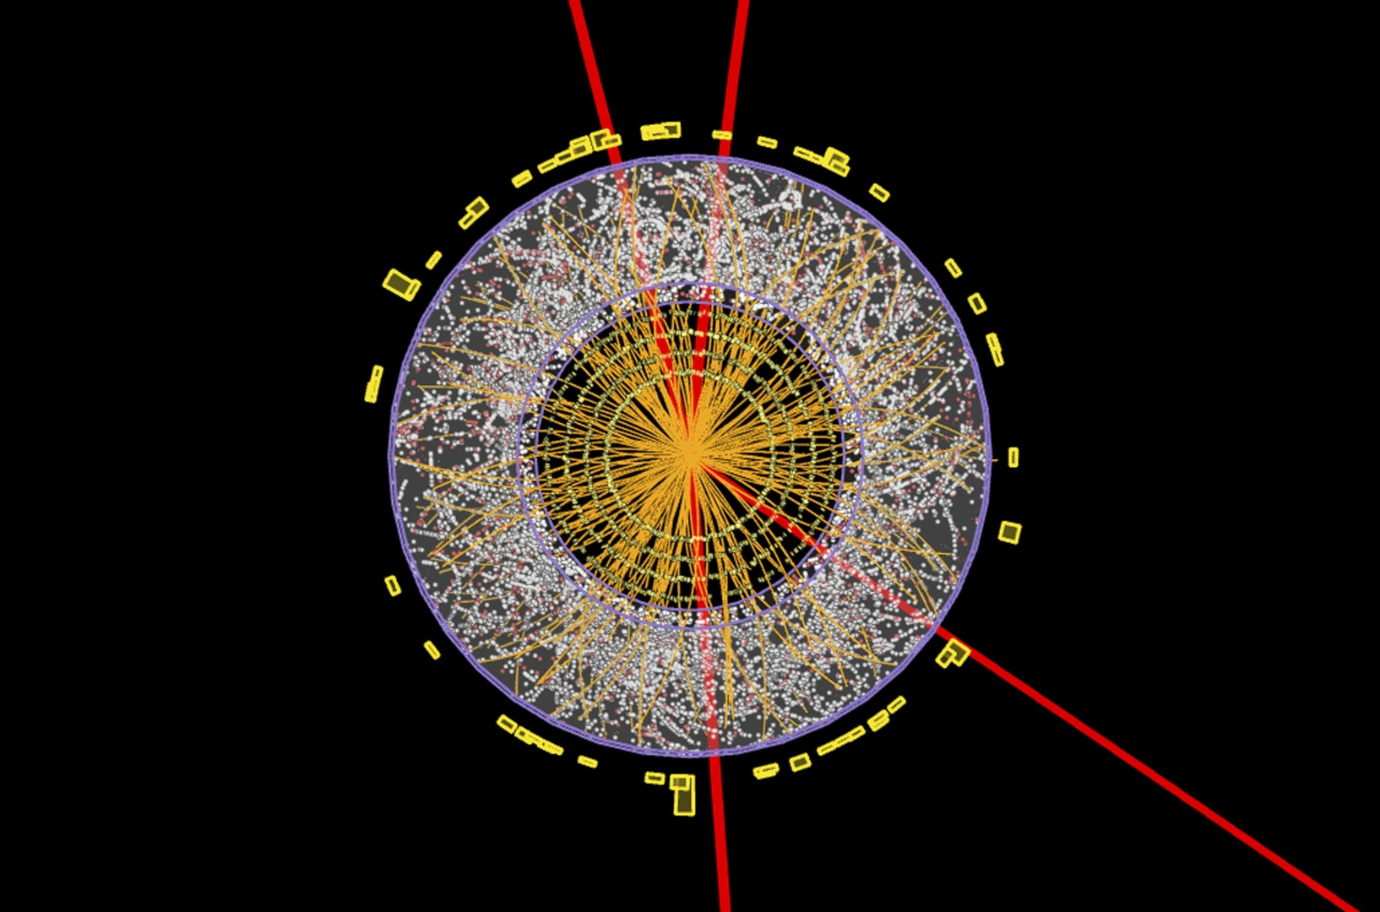Graphic of a transverse section through a detector showing one of the numerous particle collision events recorded during the search for the Higgs boson. – Atlas Collaboration/CERN

**Around the turn of the 4th century BC**, the Greek philosopher Democritus caught the smell of baking and thought that little bits of bread must be floating through the air and into his nose. He called the little bits “atoms” (meaning “uncuttable”) and imagined them as tiny spherical balls.

But atoms are not little solid spheres. They are made of even smaller bits, called particles.

Scientists’ best description of those particles and the forces that govern their behaviour is called the Standard Model of particle physics, or just “The Standard Model”.

The Standard Model categorises all of the particles of nature, in the same way that the periodic table categorises the elements. The theory is called the Standard Model because it is so successful it has become “standard”.

And no, there is no Economy Model, nor a Deluxe one.

There are, however, still a few kinks to be ironed out (as well as a couple of whopping omissions). That’s why it is sometimes called the “Theory of Almost Everything”.

How did it all kick off?

Back in the early 20th century, scientists thought there were only three fundamental particles in nature: protons and neutrons, which make up the nucleus of an atom, and electrons that whizz round it.

But in the 1950s and 1960s physicists started smashing these particles together and some of them broke. It turned out the protons and neutrons had even smaller particles inside them.

Many dozens of new particles were discovered – and for a while, nobody could explain them. Physicists called it the “particle zoo”.

In the 1970s, physicists such as Murray Gell-Mann found an order amongst the chaos. The step they took was similar to the one Russian chemist Dmitri Mendeleev took to find an order to the chemical elements in his periodic table.

The new ordering of the particles explained many of the properties of the newly discovered particles, as well as correctly predicting some new ones.

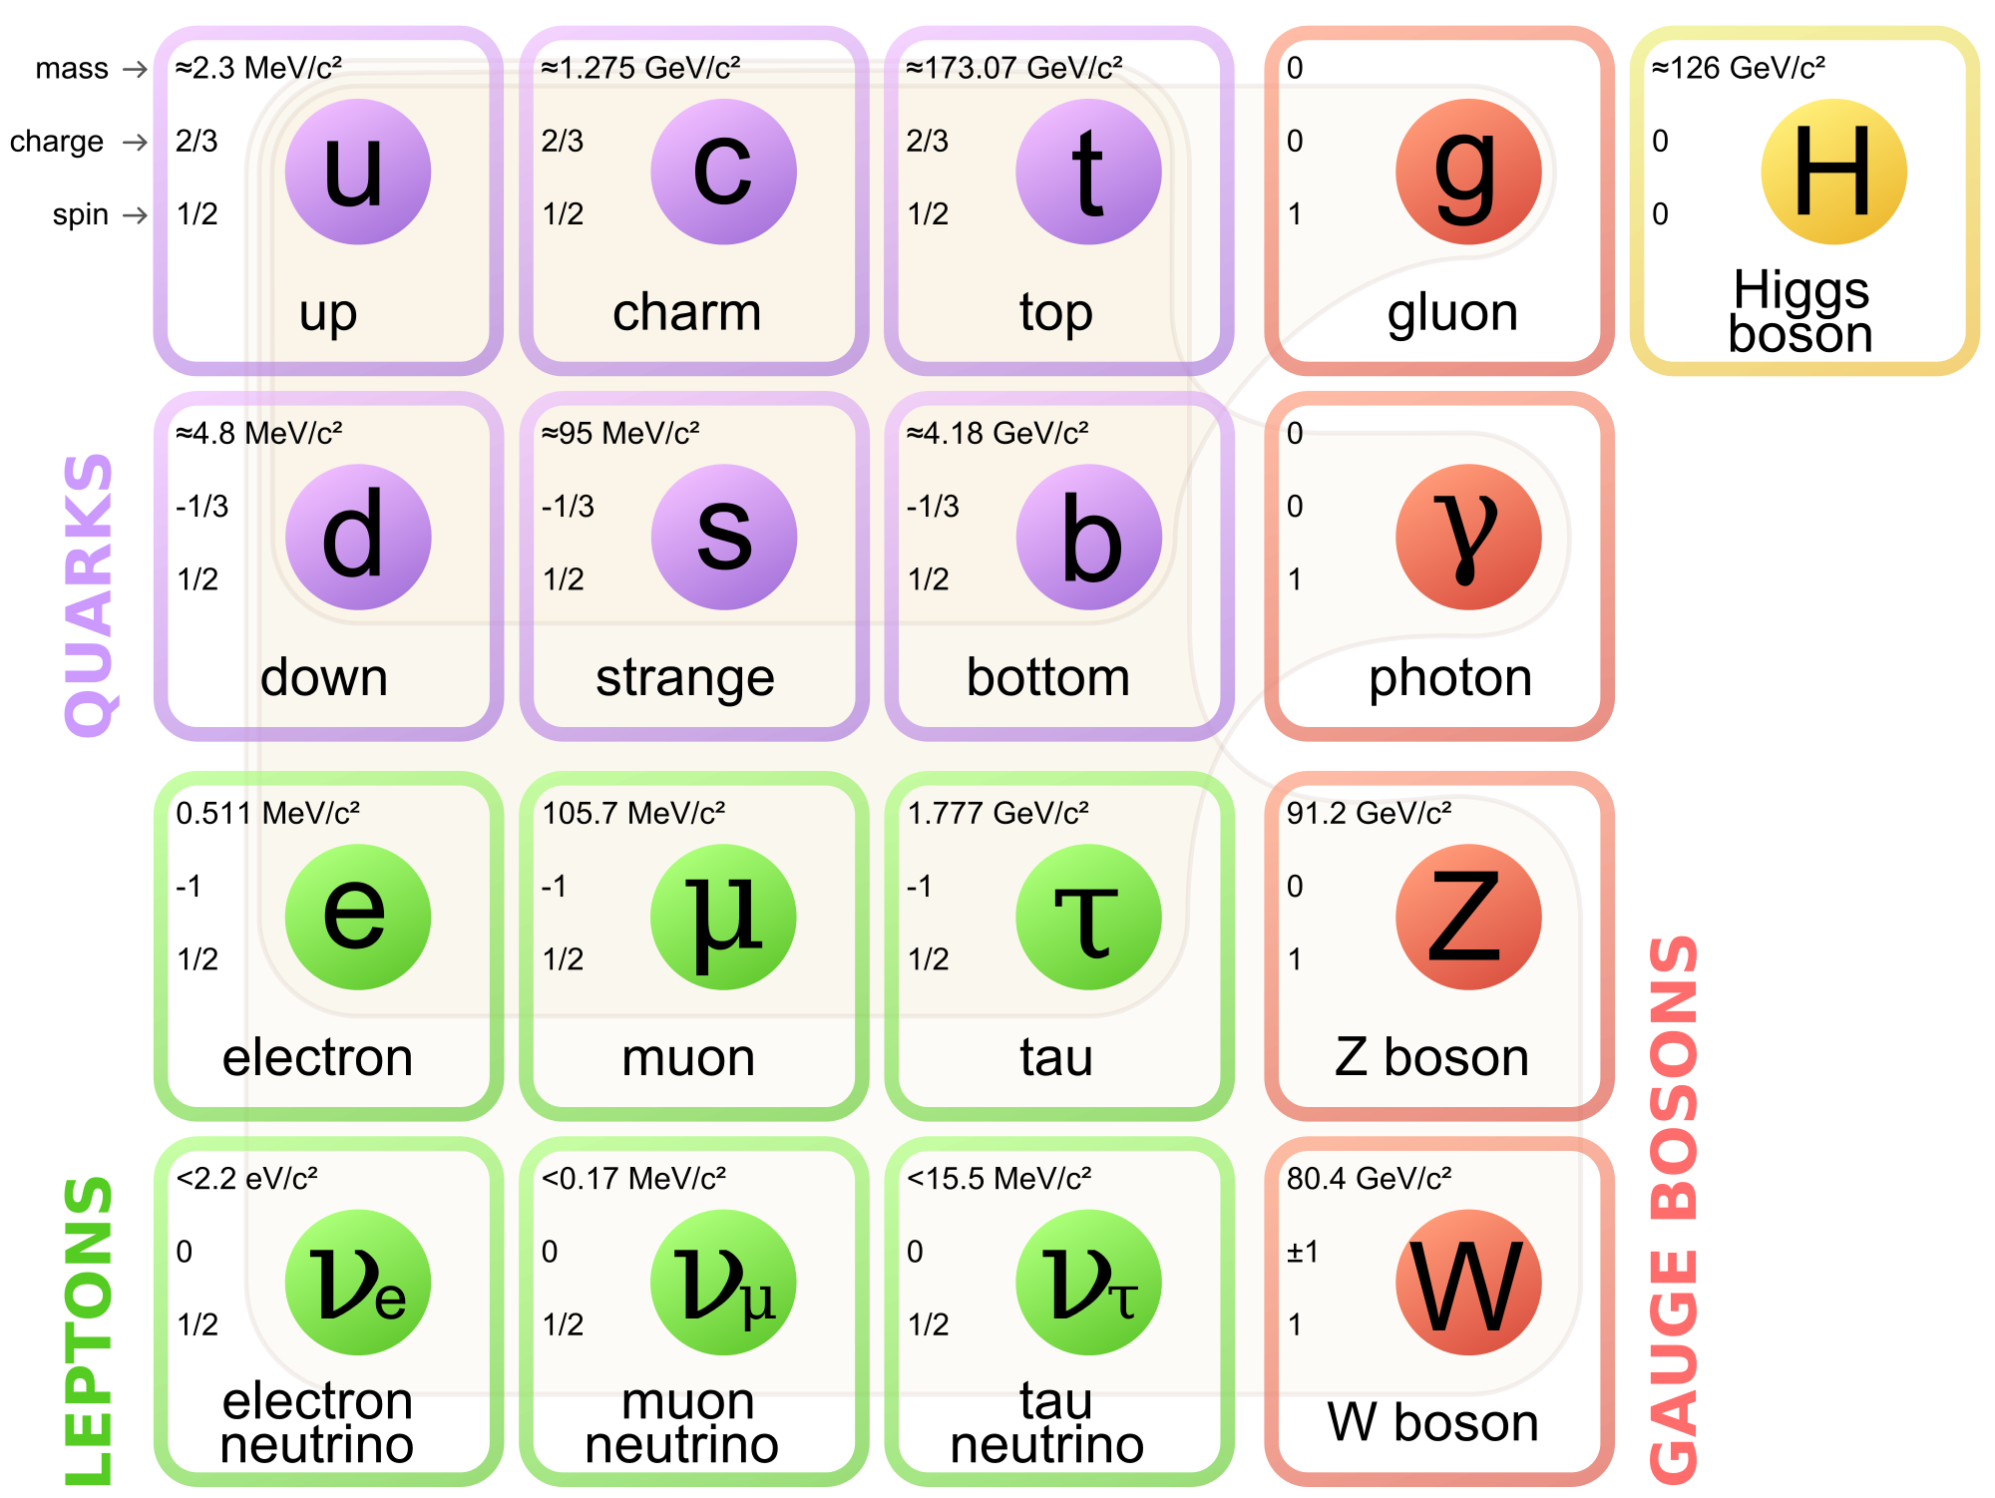These 17 fundamental particles make up the Standard Model of particle physics. – MissMJ/Wikimedia Commons

Meet the family

The particles of the Standard Model make up one big family. Your first introduction can be daunting, a bit like attending a gathering with a lot of distant cousins you’ve never heard of. No matter how strange these cousins are, it is important to remember that they are all related.

The basics

Gell-Mann and others placed the particles in two main categories: fermions and bosons.

Fermions, such as the electron, make up the stuff we call matter. Bosons, such as the photon, transmit forces.

Fermions are subdivided again into two kinds of particles, depending on the forces they feel. These are the quarks and the leptons (see below).

Forces of nature

Particles communicate with one another via four forces: electromagnetism, the strong force, the weak force and gravity.

The Standard Model describes the first three (gravity does not feature in the Standard Model, as explained below).

Different particles communicate through different forces, similar to the way people can communicate in different languages. For example, only the quarks speak “gluon”. While electrons can speak “photon” as well as “W boson” and “Z boson”.

Electromagnetism is the force that holds electrons in an atom. It is communicated by photons.

The strong force keeps the nuclei of atoms together. Without it, every atom in the universe would spontaneously explode. It is communicated by gluons.

The weak force causes radioactive decay. It’s transmitted by W and Z bosons.

The fundamental particles

All matter is made of two types of particles known as quarks and leptons.

**Quarks**: (the purple particles in the figure) come in six “flavours”, all with weird names. It’s useful to see them as coming in pairs to make three generations. These are “up” and “down” (first generation), “charmed” and “strange” (second generation) and “top” and “bottom” (third generation).

Only the up and down quarks are important in day-to-day life because they make protons and neutrons.

The others make only “exotic” matter, which is too unstable to form atoms. Physicists can create exotic matter in particle accelerators, but it usually only lasts a fraction of a second before decaying.

**Leptons**: there are six leptons, the best known of which is the electron, a tiny fundamental particle with a negative charge.

The muon (second generation) and tau (third generation) particles are like fatter versions of the electron. They also have negative electric charge, but they are too unstable to feature in ordinary matter.

And each of these particles has a corresponding neutrino, with no charge.

**Neutrinos** deserve a special mention because they are perhaps the least understood of all the particles in the Standard Model.

They are fast but interact only through the weak force, which means they can easily zip straight through a planet. They are created in nuclear reactions, such as those powering the Sun’s core.

Hadrons: the composite particles

Now that we know the fundamental particles of nature, we can begin to stack them together in different ways to make bigger particles.

The most important composite particles are the baryons, made of three quarks. Protons and neutrons are both kinds of baryon.

The European Organisation for Nuclear Research's (CERN) biggest particle collider smashes protons together. Because protons are a kind of hadron, it’s called the Large Hadron Collider, or LHC.

Antimatter: double or nothing?

As far as we know, all quarks and leptons have twin particles of antimatter. Antimatter is like matter except it has the opposite charge. For example, the electron has a counterpart that’s exactly the same mass, except with positive charge instead of negative. When a particle of matter meets its antimatter twin, they both annihilate in a burst of pure energy.

Antimatter is incredibly rare in the Universe, although it does have some important roles in technology. Positron emission tomography (PET) scanners, for instance, use the annihilation of positrons to see inside the body.

One of the great mysteries of physics is why the Universe is made almost entirely of matter. Many particle physicists are striving to answer it.

Atoms: composites of composites

The bread that Democritus sniffed is made of only the first generation of fundamental particles.

Up and down quarks bind together through the strong force to make protons and neutrons, and the strong force also sticks them together to form the nucleus of an atom.

Electrons orbit the nucleus in arrangements determined by quantum mechanics (see our primer quantum physics for the terminally confused).

The Higgs: the god particle

You probably noticed the loner off to the right side of particle table – the Higgs boson. The Higgs is a special kind of particle that gives the other fundamental particles their mass.

The idea is that there is a field existing everywhere in space. And when particles move through space, they tend to bump into this field, and this interaction slows them down (similar to how it’s more difficult to move through water than air). This interaction is what gives fundamental particles their mass.

Some particles such as photons and gluons don’t interact with the Higgs field, so are massless.

Just as photons communicate the electromagnetic force, the Higgs Boson communicates the Higgs Field.

The Higgs Boson was a theoretical particle until 2013 when CERN announced it had been discovered at last, although scientists are still uncovering its properties.

What's missing?

Gravity

The biggest hole in the Standard Model is the lack of gravity. The fourth force of nature just does not fit into the current picture.

Gravity is also incredibly weak compared to the other forces (the strong force is 100,000,000,000,000,000,000,000,000,000,000,000,000 times stronger than gravity, for example).

Some physicists think gravity is also transmitted by a kind of particle, called a graviton, but so far there is no evidence that this particle exists.

Neutrino mass

The neutrino is so tiny compared to all the other particles that it really begs an explanation. It’s possible that the neutrino doesn’t get its mass from the Higgs in the same way other particles do.

**Dark Matter:** For observing the Universe, it looks like a huge portion of it is made of Dark Matter – a new kind of stuff that doesn’t interact with regular matter and so is probably missing from the Standard Model entirely.

Supersymmetry

Some physicists are looking for extensions to the Standard Model to explain these mysteries. Supersymmetry is one extension where every particle has another twin with higher mass.

Some of these particles would interact very weakly with ordinary stuff and so could be good candidates for Dark Matter.

**Einstein, Friedmann & Relativity**

* [Einstein](http://www.atnf.csiro.au/outreach/education/senior/cosmicengine/einstein.html#einsteinanchor)
* [Special Relativity](http://www.atnf.csiro.au/outreach/education/senior/cosmicengine/einstein.html#specialrel)
* [General Relativity](http://www.atnf.csiro.au/outreach/education/senior/cosmicengine/einstein.html#genrelativity)
* [Friedmann](http://www.atnf.csiro.au/outreach/education/senior/cosmicengine/einstein.html#friedmann)

Albert Einstein (1879 - 1955)

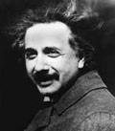

Credit: [*Emilio Segre Visual Archives*](http://www.aip.org/history/esva/)

Einstein

Albert Einstein is probably the most recongnisable and famous scientist in the world today even though he died six decades ago. 2005 was celebrated as the World Year of Physics to commemorate the centenary of the papers he wrote in 1905 on three key topics in Physics:

1. **The photoelectric effect and the photon**. Einstein applied the concept of the discrete package of energy, the quantum, discovered by the German physicist **Max Planck** to explain the *photoelectric effect*. Attempts to explain this effect, in which ultraviolet or blue light knocked electrons off a metal plate when even high levels of red light could not, using classical physics had all failed.   
   By considering light to behave as discrete particles called *photons* rather than as a wave Einstein was able to successfully account for the observations. Light therefore was quantised, with the energy of a photon being proportional to its frequency. It was for his work on this topic and not relativity that Einstein was awarded the [Nobel Prize in Physics in 1921](http://nobelprize.org/physics/laureates/1921/index.html).
2. **Brownian motion and the size of atoms**. In 1827 the Scottish botanist **Robert Brown** observed and described the random motion of tiny grains of pollen under a microscope. This motion was subsequently termed *Brownian motion* defied attempts by scientists to satisfactorily explain it until 1905. Einstein accounted for this motion by stating that minute atoms move randomly in a liquid and collide with the pollen grains. He proposed a means to measure both the size and average speed of the atoms. This work was instrumental in convincing scientific sceptics of the reality of atoms.
3. **The special theory of relativity**. Einstein's work on special relativity changed the way we view time and mass. The term 'special' in his theory refers to the fact that Einstein limited his discussion to the special case of non-accelerated objects, that is objects moving in a straight line at constant speed. The key concept in special relativity is that the speed of light, *c*, is the same for any observer in an *inertial* (ie unaccelerated) frame of reference. Two observers, one moving much faster then the other, both measure the speed of light to be the same. from this premise we get some interesting phenomena.  
   Rather than being fixed, the mass of an object is dependent on its speed. As an object approaches the speed of light, its mass increases. This *relativistic* mass increase has been measured to high precision in many situations. Einstein also realised that a direct realtionship existed between energy and mass, indeed that the two were interchangeable. This gave rise to his famous equation:

*E* = *mc2* (**2.1**)  
where *E* is energy, *m* is the mass of an object and *c* is the speed of light in a vacuum.

The importance of this relationship is that a small amount of mass can be converted into a large amount of energy. The realisation of this ultimately led other scientists to the discovery of nuclear *fission* (the splitting of the atom) and the development of atomic weapons in the Second World War. It also provided an explanation for the source of energy in stars such as our Sun. Nuclear *fusion*, in which light nuclei such as hydrogen fuse together produce a new, heavier nucleus in which the mass is slightly less than the sum of the original nuclei. A small amount of mass is converted into high energy gamma ray photons.   
Special relativity also introduces the concepots of *time dilation* and *length contraction*. These can be used to explain the detection at the Earth's surface of muons from cosmic ray showers even though they should decay before they have time to reach it.

General Relativity

By 1916 Einstein had extended his earlier work on relativity to encompass more general situations including gravity and accelerated motion. This became known as the general theory of relativity and is a theory of gravity, the key long-range force in the Universe. He derived it from a key postulate, the *principle of equivalence* between inertial and gravitational forces. An object with mass not only possesses inertia but actually warps or curves space around it. It affects spacetime. The concept of four-dimensional *spacetime* had been applied to relativity by **Minkowki** in 1908. Motion and forces act along straight lines but where space is curved due to the presence of matter, the path followed by an object or light thus also appears curved.

The predicted curvature of light around a massive object was dramatically verified by the British astrophysicist, **Sir Arthur Eddington** in 1919. Observations made by his teams in Brazil and West Africa measured the apparent shift in light from a star close to the Sun during a solar eclipse, fitting Einstein's predictions. This successful confirmation was largely responsible for the rapid acceptance of Einstein's work and his global fame.

Einstein showed that Newton's theory of gravity was really a subset of more general conditions covered by general relativity. General relativity can account for the observed precession of the perihelion of Mercury about the Sun and the observed difference in hydrogen maser clocks in satellites orbiting Earth compared with those on the ground.

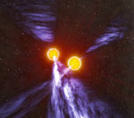

Credit: John Rowe Animations

An artist's impression of the double pulsar system.

General Relativity has been tested to incredible precision. The recent [discovery of a double pulsar system](http://www.atnf.csiro.au/news/press/double_pulsar/) J0737-3039 using the Parkes radio telescope in which two pulsars orbit each other provides an outstanding natural laboratory for testing general relativity in extreme conditions. Numerous examples of gravitational lensing have now been observed by astronomers. [Gravity Probe B](http://einstein.stanford.edu/), launched in 2004, uses gyroscopes in a polar-orbiting satellite space to test the concept of frame-dragging. This was a previously untested aspect of general relativity.

General relativity is not just on interest to astrophysicists and gravitational wave physicists. The modern GPS satellite system can only function due to the application of general relativistic corrections to the orbits of each of the over twenty satellites in the system. The growing commercial, military and safety applications of such navigation systems show the relevance of general relativity in the modern world.

Aleksandr Friedmann (1888 - 1925)

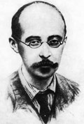

Credit: [*Emilio Segre Visual Archives*](http://www.aip.org/history/esva/)

Friedmann

Friedmann was a Russian mathematician and meteorologist who lived a short but eventful life. During the revolution of 1917 whilst besieged by White Russian forces in Petrograd (now St. Petersburg) he heard about Einstein's work on general relativity. He started to derive solutions, publishing his findings in 1922. His key insight was to realise that there was no unique solution to Einstein's equations, rather there was a whole family of solutions possible. This family of solutions thus allowed for different cosmological models of the Universe.

In Friedmann's models the only force that is considered is gravitation. His model universes are *homogeneous* (the same everywhere on a large enough scale) and *isotropic* (look the same in every direction). Most importantly they incorporate the concept of *expansion* and in some cases, contraction. Einstein himself had viewed the Universe as static. Friedmann thus provided the theoretical framework for an expanding Universe within the spaceteime and mathematics of general relativity. Unfortunatley he contracted typhoid and and died in 1925 during the Russian civil war before his work became widely known.

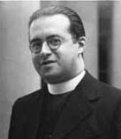

Credit: *AIP Emilio Segre Visual Archives*

Georges Lemaître

Friedmann's work was independently verified in 1927 when the Belgian astrophysicist and priest **Georges Lemaître** derived the same solutions, unaware of Friedmann's earlier work. Lemaître also realised that the newly discovered galaxies could be used to show the expansion of the Universe.

The observational evidence for this was forthcoming through the work of [Edwin Hubble](http://www.atnf.csiro.au/outreach/education/senior/cosmicengine/hubble.html).

Lemaître went on to apply thermodynamics and quantum theory to consider the entropy or state of order of the Universe. He realised that if the disorder increased over time then the converse should also apply if one went back in time. This led him in 1927 to propose the concept that the Universe began as a*primeval atom.* His theory suggested that all of the mass-energy (1051 kg) of the universe was concentrated in a single super-atom about one astronomical unit across. The primeval atom would then fragment and the universe expand. Lemaître's concept was a precursor of the [big bang](http://www.atnf.csiro.au/outreach/education/senior/cosmicengine/bigbang.html) model.

**Edwin Hubble & the Expanding Universe**

**From Australia Telescope National Facility**

Edwin Hubble (1889 - 1953)

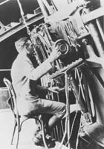

Credit: [*Emilio Segre Visual Archives*](http://www.aip.org/history/esva/)

Edwin Hubble at the camera on the Hooker 100 inch telescope on Mt Wilson.

Trained initially as a lawyer, Edwin Hubble moved to astronomy in 1914, working at the famous [Yerkes Observatory](http://astro.uchicago.edu/yerkes/) near Chicago. He went on to have a profound influence on our understanding of the Universe. Using the largest telescope of his time, the 100 inch Hooker telescope on [Mount Wilson](http://www.mtwilson.edu/) in California, he helped resolve one of the great debates in early twentieth century astronomy.

Island Universes

One of the unsolved problems in early twentieth century astronomy was the question of what were nebulae? These gaseous, fuzzy clouds were thought by some astronomers to be embryonic solar systems forming while others thought that they were "island universe" like our own Milky Way galaxy. The advent of spectroscopy and photography in that late nineteenth century when used on the latest generation of large reflecting telescopes in the early twentieth century provided astronomers with the tools to study these objects.

Hubble used the 100 inch Hooker Telescope on Mount Wilson, then the largest telescope in the world, to study the Andromeda Nebula, M 31. In 1923 he identified some of the stars within it as *Cepheid* variables. These are periodic variable stars, that is stars that vary their brightness in a regular way. Earlier, in 1908 **Henrietta Swan Leavitt**, working at the Harvard College Observatory discovered that Cepheid variables in fact obey a period-luminosity relationship; the longer the period of a Cepheid, the more intrinsically luminous it is. This allowed Hubble to observe the Cepheids over time and measure their varying brightnesses to determine their periods. He could then apply the period-luminosity relationship to calculate the distance to the stars and hence the distance to the Andromeda Nebula that they were in. By 1924 Hubble had calculated that the distance to the Andromeda Nebula was 900,000 light years.

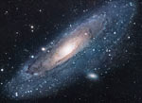

Credit: [*NASA APOD*](http://antwrp.gsfc.nasa.gov/apod/astropix.html)

The Andromeda galaxy, M31.

Supporting evidence came from the work of **Vesto Sliphe**r at the Lowell Observatory in Arizona. He had started measuring the *Doppler shift* of spectral lines from spiral nebulae in 1912. By 1925 he had shown that most exhibited redshifts in their spectral lines. He interpreted this as meaning that they were in fact moving away relative to us so their spectrum was shifted to longer (ie *redder*) wavelengths). Whilst he calculated that the Andromeda spiral was moving towards us at 300 km.s-1 he soon found others moving away at 1,100 km.s-1. These speeds exceeded that of any known star in the Milky Way.

Taken together the evidence eventually convinced astronomers that "spiral "nebulae" such as Andromeda were in fact separate "island universes" of billions of stars like our own Milky Way but more distant. We now call these *galaxies* instead of island universes.

The Expanding Universe & Hubble's law

Hubble, aided by **Milton Humason** extended the work of Slipher by using the larger Hooker telescope. He took long exposures of the spectra of faint galaxies. By measuring the amount of shift of specific spectral lines relative to those produced by reference arc lamps in the spectrograph he was able to calculate values for the galaxy velocities. A few nearby galaxies had velocities that meant they were moving towards our own Milky Way, that is their lines were blueshifted but most exhibited redshift and hence had *recession velocities*. The majority of galaxies therefore appeared to be moving away from our own galaxy. Hubble found that that those with a smaller image in a photograph had higher redshifts. This is shown in the diagram below that shows the images and spectra of some of the galaxies he observed.

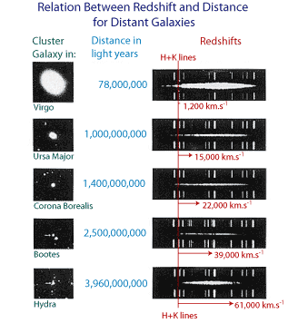

Hubble's observations of galaxies with the redshift in their spectral lines.

He inferred that galaxies were similar to each other in size so those that appeared smaller must be further away. By plotting the velocity of the galaxies against their distance he came across an interesting relationship. This is now known as Hubble's law and is shown in the following plot.

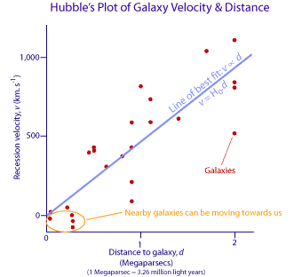

Hubble's distance-velocity relationship for galaxies based on his original data. This is now known as *Hubble's Law* and is interpreted as evidence for an expanding Universe.

If you study the above plot you will see that the more distant a galaxy is, on average, the faster it is receding from us. In fact Hubble realised he could fit a linear relationship to his data, as shown by the pale blue line of best fit. The slope of this line is a constant and is now known as the *Hubble constan*t, *H0*. This relationship is expressed mathematically as:

*v* ∝ *d*  
so: *v* = *H0d* (**2.2**)   
where *H0* is Hubble's constant, *v* is the recession velocity and *d* is the distance.

Hubble's velocity-distance relationship, published in 1929, suggests that once we look beyond the gravitational effects of close galaxies within the local group, galaxies are moving away from one another. Not only are they moving away but the more distant galaxies appear to be moving away faster than closer ones. This then suggests that the Universe is expanding and indeed this is now the most widely-accepted interpretation of the data. The other key point arising from the relation is that if we go back in time galaxies must have been closer together, space was smaller. If you extrapolate back far enough the Universe must have been concentrated at a point in space.

If we assume that *H0* provides us with a value for the current rate of expansion then its inverse, that is 1/*H0* tells us the *Hubble time* which is a measure of the age of a universe expanding at a constant rate. Hubble calculated a value for *H0* of about 500 km. s-1. Mpc-1. (1 Mpc-1 is 1 megaparsec or about 3.26 million light years. Astronomers use the parsec as the unit of distance measure rather than the light year. Details about the [parsec](http://www.atnf.csiro.au/outreach/education/senior/astrophysics/astrometry1.html#astromparsec) can be found in the Year 12 Astrophysics topic). This value results in an age of the Universe of 2 × 109 years, that is 2 billion years.

Even in Hubble's day this age proved problematic as it clashed with radiometric dating values for the age of the Earth that ranged from 3 to 5 billion years and other evidence on the age of stars. Obviously this posed a dilemma - the Universe could not be younger than the stars or planets it contained! The problem was eventually resolved in the 1950s when the recalibration of the Cepheid period-luminosity relationship provided an age for the Universe in the range of 10-20 billion years.

Even today astronomers spend a lot of time trying to determine a more precise and accurate value for *H0* and thus also an age for the Universe. The age actually also depends on what model is assumed for the [geometry of the Universe](http://map.gsfc.nasa.gov/m_uni/uni_101shape.html); flat, open or closed. Recent projects involve a range of methods and do not just rely on observations of Cepheids to calibrate their data. Estimates based on observations of the [cosmic microwave background radiation](http://www.atnf.csiro.au/outreach/education/senior/cosmicengine/bigbang.html#cmbr) (CMBR) by the[WMAP probe](http://map.gsfc.nasa.gov/m_uni/uni_101age.html) and other CMBR experiments currently suggest **an age of 13.7 billion years ± 1%** based on *H0* = 71 km. s-1. Mpc-1+4/-3. This agrees closely with the value determined by the [Hubble Key Project](http://map.gsfc.nasa.gov/m_uni/uni_101expand.html) team that used the Hubble Space Telescope to observe Cepheids in galaxies and calibrated their values with other techniques. They obtained a value of *H0* = 70 km. s-1. Mpc-1 &plusmn 10%

George Gamow (1904 - 1968)

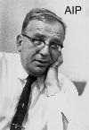

Credit: *AIP Emilio Segre Visual Archives*

George Gamow

**George Gamow**, a Ukrainian-born, US-based physicist and former student of Friedmann's, made his mark early by applying quantum theory to explain how alpha particles can be ejected from nuclei in alpha decay. Moving from the USSR in 1931 he settled in the US and continued his work on stellar evolution and beta decay. He was particularly interested in trying to solve the problem about the origin of the elements.

**Hans Bethe** had already shown in the 1930s how helium could be synthesised inside stars through fusion of hydrogen nuclei. He had also explained how protons and neutrons added to carbon nuclei could form heavier elements. Gamow had realised from Hubble's work that the early Universe must have been much smaller, hotter and denser than it is now. In the late 1940s with his students **Ralph Alpher** and **Robert Herman** he calculated that helium could form from the fusion of protons (that is, hydrogen nuclei) and neutrons. This *nucleosynthesis* would cease once the available neutrons were used up and the Universe had expanded and cooled sufficiently. They also realised that the Universe should be filled with background microwave radiation, the remnant of the original big bang now cooled to about 50 kelvin. This radiation would have the spectral characteristics of a blackbody.

Gamow's theory of the nucleosynthesis of primordial helium accounted for the observed abundance of helium compared with hydrogen in the Universe whereas stellar nucleosynthesis could not. His prediction of remnant radiation was neglected by others until the 1960s but was to provide the key evidence in support of the big bang model for the Universe.

**The Big Bang & the *Standard* Model of the Universe**

**From Australia Telescope National Facility**

What is the Big Bang?

The "Big Bang" is the term given to what is currently the most widely accepted scientific model for the origin and evolution of the Universe. This model has supplanted other models such as the [Steady State theory](http://www.schoolsobservatory.org.uk/study/sci/cosmo/internal/steady.htm) proposed by **Hoyle**, **Bondi** and **Gold** in the 1940s. Indeed it was Fred Hoyle who coined the term "big bang" as a derisory one in an interview in the 1960s.

In the Big Bang theory the Universe comes into existence, creating time and space. Initially the Universe would have been extremely hot and dense. It expanded and cooled. Some of the energy involved was turned into matter. Current observations suggest an age for the Universe of about 13.7 billion years.

The current success of the big bang model relies on several key areas of observational evidence and predictions. These are discussed briefly below.

Evidence for the Big Bang Model

There are several key areas of observational support for the big bang model. These are:

1. **Observed recession of galaxies**: The consensus among astronomers is that [Hubble's relationship](http://www.atnf.csiro.au/outreach/education/senior/cosmicengine/hubble.html#hubblelaw) between the distance to galaxies and their recession velocity is due to the expansion of space. More distant galaxies or clusters of galaxies exhibit higher redshift of their spectral lines than closer galaxies. This is then interpreted as more distant galaxies receding from us faster than closer ones. Note it is important to realise that it is the space between galaxies that is expanding. Galaxies themselves do not appear to expand as the local effects of gravity dominate over any space expansion.
2. **Cosmic Microwave Background Radiation**: In 1965 two scientists working for Bell Telephone Laboratories, **Arno Penzias** and **Robert Wilson** were adapting a horn-shaped antenna near New York for use in radio astronomy. They encountered noise in the system and despite repeated and thorough attempts were unable to remove it or find its cause. They eventually realised that this "noise" was in fact remnant radiation from the big bang. Such radiation had been predicted by [Gamow](http://www.atnf.csiro.au/outreach/education/senior/cosmicengine/hubble.html#gamow) in the late 1940s. As the Universe expanded it cooled so that today the background radiation corresponds to a temperature of 2.725 K and has a black body spectrum.

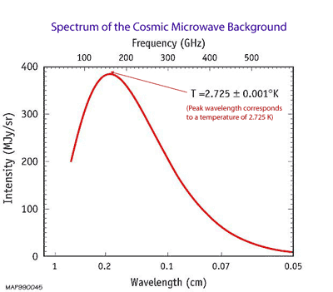

Credit: *NASA, WMAP*

This plot shows the black-body nature of the cosmic microwave background radiation. The spectrum corresponds to background radiation with a temperature of 2.725 K. These measurements were made by the FIRAS instrument on the COBE satellite. The error bars for each measurement are smaller than the width of the red line.

Over the last 15 years observations of this cosmic microwave background radiation (CMBR) from space-based missions such as [COBE](http://lambda.gsfc.nasa.gov/product/cobe/) and [WMAP](http://map.gsfc.nasa.gov/)and balloon-based missions such as [BOOMERanG](http://cmb.phys.cwru.edu/boomerang/) that operated in the Antarctic have provided a wealth of details. We can now view the slight fluctuations or anisotropies in the CMBR with unprecedented detail and compare observations with theory more thoroughly. The image below shows how the resolution of the CMBR has improved since its discovery in the 1960s. These slight fluctuations in the CMBR intensity are thought to provide information about slight variations in density in the early Universe.

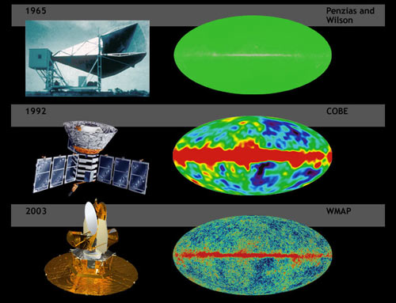

Credit: *NASA,*[*WMAP*](http://map.gsfc.nasa.gov/m_ig/ig_universe1.html)

Comparison of the level of detail of fluctuations in the CMBR from the 1960s through to the current WMAP mission.

1. **Ratios of primordial elements.** Astronomers are able to measure the relative amounts of the light nuclei hydrogen, deuterium (an isotope of hydrogen with one proton and one neutron), helium-3, helium-4 and lithium-7 in distant, unmixed clouds of primordial gas. The relative abundances of these nuclei correspond with the calculated predicted ratios from the Big Bang model.
2. **Observed evolution of extragalactic objects over cosmic time**. Evidence for this initially came from radio surveys which showed that the more distant (hence older) parts of the Universe appeared to contain stronger radio sources than the local region. Quasars, for instance, are not found in our local region but are far more common at redshifts of 2 or 3.   
   Recent observations by the Hubble Space Telescope and other telescopes have provided our deepest ever views of the Universe and clearly show evidence of galactic evolution and earlier stages in their formation.

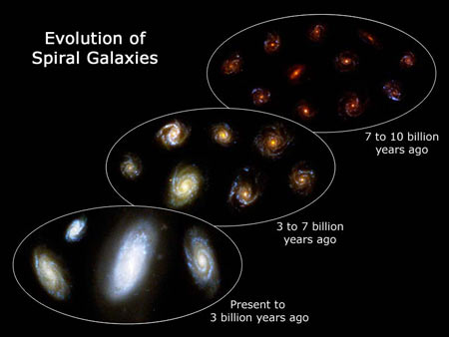

Credit: [*NASA*](http://www.nasa.gov/)*,*[*ESA*](http://spacetelescope.org/)*, F. Summers and Z. Levay ([STScI](http://www.stsci.edu/))*

Recent observations by the HST show the evolution of spiral galaxies over time.

Formation of Matter

All matter, including the atoms in our bodies, the air we breathe and the gas in the Sun is composed is combinations of fundamental particles that were created during the Big Bang and subsequent evolution of the Universe. Before giving an outline of the key stages in the formation of matter we need to review the fundamental particles and forces in the Universe.

Fundamental particles, the building blocks of the Universe

Our current understanding of physics allows us to model events in the Universe nearly, but not quite back to the moment of the big bang. Significant developments in our understanding of the very early Universe are due to advances in high-energy [particle physics](http://particleadventure.org/particleadventure/) and particle accelerators such as those at[CERN](http://hands-on-cern.physto.se/). According to the "Standard Model" of particle physics we now know that all the matter around us is composed of combinations of only a few fundamental particles. These twelve particles fall into two families, *quarks* and *leptons*.

Quarks are the particles that group together to form *hadrons*. Hadrons made of three quarks in turn are called *baryons*. The most familiar baryons to us are the protons and neutrons that comprise the nuclei of the atoms in our bodies and the rest of the Universe. A proton comprises two *up* quarks and one *down* quark, whilst a neutron has two down quarks and only one up quark. If you study the following table you will see that quarks have charges that are fractions of the charge of an electron, *e*. Hence the overall or net charge of a proton = 2 × (+2*e*/3) - 1 ×(-1*e*/3) = +1*e* and the overall charge of the neutron is 0.

Leptons include three charged particles, the *electron*, *muon* and *tau* particle. Each of these has an associated *neutrino* particle that is neutral.

Together these twelve particles are the building blocks of *matter*. Interestingly though, each of them has a corresponding *antiparticle*. These differ only in having the opposite charge but have the same mass as the corresponding matter particle. These antiparticles collectively are known as *antimatter*.

The Fundamental Particles

| **Family** | **Name** | **Charge** | **Rest Mass** | **Symbol** |
| --- | --- | --- | --- | --- |
| **Quarks** | up | +2*e*/3 | ~ 4 MeV | u |
| charm | ~ 1,250 MeV | c |
| top | ~1,784,000 MeV | t |
| down | -1*e*/3 | ~ 6 MeV | d |
| strange | ~ 110 MeV | s |
| bottom | ~ 4,100 MeV | b |
| **Leptons** | electron | -*e* | 0.511 MeV | e- |
| muon | 105.7 MeV | μ- |
| tau | 1784 MeV | τ- |
| electron neutrino | 0 | <2.5 eV | νe |
| muon neutrino | <170 keV | νμ |
| tau neutrino | <18 MeV | ντ |

Quarks can be grouped into three families, the up & down, the charm & strange and the top and bottom quarks. Each successive family has more massive particles. This trend is also followed by leptons; the electron and its neutrino are lighter than the muon and muon neutrino which in turn is lighter than the tau and tau neutrino.

Fundamental Forces

All interactions within the Universe arise due to only one of four fundamental forces:

The Fundamental Forces

| **Force** | **Example** | **Relative Strength (at 10-15m)** | **Range** | **Exchange Particle** |
| --- | --- | --- | --- | --- |
| **Gravitational** | Acts on all objects with mass. Responsible for orbit of Earth around Sun. Binds stars, planets and galaxies together. | 10-38 | Long range (infinite) | Described by general relativity as due to curvature of space-time.  Graviton is hypothesised exchange particle |
| **Weak** | Involved in transmutation of a neutron to a proton in Β- decay. | 10-13 | <10-18m | *W*+, *W*- and *Z*0 bosons |
| **Electromagnetic** | Interactions between charged particles. Responsible for light and chemical properties of matter and | 10-2 | Long range (theoretically infinite but limited due to canceling effects of + and - charges and magnetic poles) | photon |
| **Strong** | Binds nucleons (protons and neutrons) together in nucleus | 1 | distance of adjacent nucleons in nucleus (10-15m) | gluons |

Immediately following the Big Bang all four forces are thought to have been combined and governed by one one *Theory of Everything*. As the Universe expanded the energy density dropped and the forces started to split from each other. The first split occurred when gravity separated from the others at the *Planck time*, about 10-43 s. The Universe was at a temperature of 1032 K at this stage. Electromagnetism and the strong and weak nuclear forces were still combined as a*Grand Unified force*.

At 10-35s and a temperature of 1027 K the strong nuclear force separated from the electro-weak force. These two then separated at about 10-12s when the Universe was at 1015 K to give rise to the four distinct forces in our Universe today. Whilst gravity is the weakest of all these forces it now governs the evolution of the Universe due to its long range influence and the amount of matter present.

Particle Production and Nucleosynthesis

The intense energy released in the Big Bang provided the source of all the matter in the Universe. Quantum physics explains the production of particle-antiparticle pairs. Whilst most of these went on to mutually annihilate each other, producing gamma photons, a very slight imbalance of matter over antimatter provided the building blocks for nuclei and atoms.

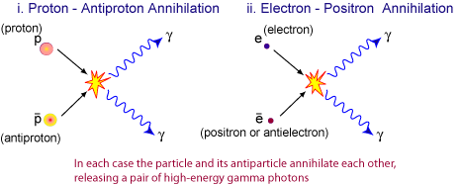

Credit: *CSIRO*

Annihilation of particle-antiparticle pairs to produce gamma photons.

Within three minutes of the Big Bang, fusion reactions between protons and neutrons had made helium and deuterium nuclei. This process is called*nucleosynthesis*. 370,000 years later the Universe had expanded and cooled enough that the electrons could form stable atoms of hydrogen and helium. At this point matter is said to *decouple* from radiation and the Universe became transparent to photons. Light could thus travel long distances. We can view this event as the CMBR. The diagram below shows one of the possible nucleosynthesis sequences responsible for the production of helium-4 nuclei from protons and neutrons. About 24% of the baryonic mass of the early Universe was helium, the other 76% hydrogen.

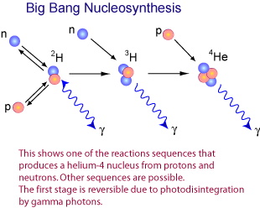

Credit: *CSIRO*

The production of helium via nucleosynthesis during the first three minutes of the Universe.

The table below provides an outline of the key events in the early history of the Universe.

Timeline since the Big Bang

| **Time since Big Bang** | **Temperature K** | **Era** | **Key Events** |
| --- | --- | --- | --- |
| 0 | ∞ | Radiation- dominated | Big Bang. Universe formed. Time before 10-43s is termed the Planck time. Our Physics can not yet describe this interval in detail. |
| 10-43s | 1032 | Gravitational force separates from the strong-electro-weak force (Grand Unified force). Microscopic black holes form & disintegrate. |
| 10-35s | 1027 | Grand unification ends (the strong force separates from the electro-weak force). Quarks, leptons and antiparticles created. Inflation occurs? Universe expands by factor of 1025. Gravitons form and decouple. |
| 10-12s | 1015 | Four fundamental forces now distinct. Leptons separate into electrons, neutrinos and antiparticles. Gravity starts to control expansion. |
| 10-6 s | 1013 | Quarks & anti quarks form protons, neutrons & antiparticles. Protons & antiprotons; neutrons & antineutrons annihilate each other leaving slight excess of protons & neutrons plus lots of photons. |
| 1 s | 1010 | Neutrinos and antineutrinos decouple. |
| 15 s | 3 × 109 | Electrons and positrons annihilate each other. Slight excess of electrons left (= number of protons so net charge of Universe is 0) plus more photons. |
| 3 minutes | 109 | Protons and neutrons fuse into helium nuclei (nucleosynthesis). Spare neutrons used up. |
| 370,000 years | 3,000 | Matter- dominated | Matter decouples from radiation - electrons orbit nuclei to form atoms. Universe becomes transparent to photons as they can now travel long distances without interacting with charged particles. This decoupling is now viewed as the 2.7 K Cosmic Microwave Background Radiation. |
| 1 billion years |  | First stars and galaxies form. Heavy elements created in supernova explosions. |
| 8.4 billion years |  | Sun and solar system formed. |
| 13.4 billion years (NOW) | 3 | Humans on Earth |

The Big Bang model successfully accounts for the formation of the light elements, hydrogen, helium and traces of lithium and their isotopes from fundamental particles. Elements heavier than helium, including the iron, carbon and oxygen in our bodies and the uranium in the Earth were all synthesised later in stars. Our bodies are made of the debris of earlier generations of stars.

Modern Cosmology

Our understanding of the Universe has undergone profound changes due to recent observations and discoveries. For some time astrophysicists have been aware that there is not enough visible matter in the Universe to account for the gravitational cohesion of clusters of galaxies or the rotation rate of spiral galaxies. These galaxies are spinning too fast for the observable matter in them to hold them together. To solve this dilemma the concept of *dark matter* has been suggested. This is matter that cannot be seen (hence *dark*) but otherwise interacts gravitationally with normal matter. A range of candidates from neutrinos, WIMPS (weakly-interacting massive particles) and MACHOS (massive astrophysical compact halo objects) have been proposed. Whilst some have now been ruled out there is still no consensus as to what dark matter is. The search continues.

Perhaps even more intriguing than the search for dark matter is the discovery, based on observations of distant supernovae, that the Universe is not just expanding but actually *accelerating*. Astrophysicists have proposed the concept of *dark energy* in the Universe. This acts as a repulsive force over the large scale, overcoming gravity. As with dark matter we do not yet know what this energy is in any detail.

These two discoveries combine to give us a very different picture of the Universe from that of a few decades ago. We now believe that all the "ordinary" matter that us, stars and galaxies are made of comprises only a small fraction of the constituents of the Universe.

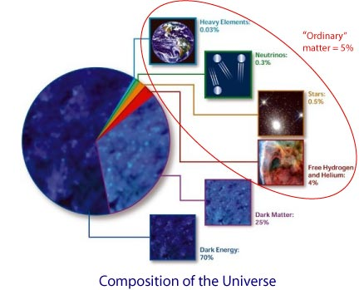

Credit: *NASA, WMAP*

"Ordinary" matter is now thought to comprise only 5% of the Universe.

This section has provided only a brief introduction to the Big Bang. There are still problems to be solved and questions to be tackled but the Big Bang model remains our best model for understanding the origin and evolution of the Universe at present. If you want to read more please go to many of the excellent external sources listed in our [links](http://www.atnf.csiro.au/outreach/education/senior/cosmicengine/cosmology_links.html) page.